**2019-11-09 qiWELLNESS for PCB and prototypes version**

Selection of R22 resistor value depending on the IL300 bin type.

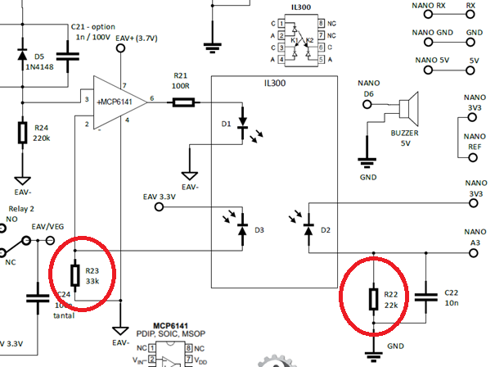

e.g.

R23 = 33k always!

If You use **IL300-H** R22=22k (letter H).

H = (1,169+1,311)/2 = 1.24 (middle of gain)

85 % * 33k / 1.24 = 0,85 * 26,6k = 22.61 - **use 22k**

Bin sorting: K3 (transfer gain) is sorted into bins that are ± 6 %, as follows:

* A = 0.557 to 0.626
* B = 0.620 to 0.696
* C = 0.690 to 0.773
* D = 0.765 to 0.859
* E = 0.851 to 0.955
* F = 0.945 to 1.061
* G = 1.051 to 1.181
* **H = 1.169 to 1.311**
* I = 1.297 to 1.456
* J = 1.442 to 1.618

If you select R22 resistant well You will calibrate the device easily.

See: Hardware calibration method <https://github.com/biotronika/miniVOLL>